My First RMarkdown Document

Arun

2022-12-08

This is an RMarkdown Document.(1)

# This is a first level header

Sample Text

## Header 2

Sample Text

### Header 3

Sample Text

# This is another first level header

## Creating Lists in RMarkdown

* List 1
* List 2
  + Item a
  + Item b
* List 3

### Bold and italics

This is **bold** text. This is *italics* text.

## Adding a table

| Col1 | Col2 | Col3 |
| --- | --- | --- |
| Arun | 123 | samosa |
| Antony | 345 | burger |
| Nesan | 456 | pakoda |

library(tidyverse)  
library(gtsummary)  
  
df <- MASS::birthwt  
  
df %>%   
 select(lwt, low) %>%   
 tbl_summary(by = low)

| **Characteristic** | **0**, N = 130 | **1**, N = 59 |
| --- | --- | --- |
| lwt | 124 (113, 147) | 120 (104, 130) |

### Using dplyr verbs

df %>%   
 group_by(low) %>%   
 summarize(mean = mean(lwt))

## # A tibble: 2 × 2  
## low mean  
## <int> <dbl>  
## 1 0 133.  
## 2 1 122.

## Adding Images to your RMarkdown Document





df %>%   
 ggplot() +  
 geom_bar(aes(x = factor(low)))

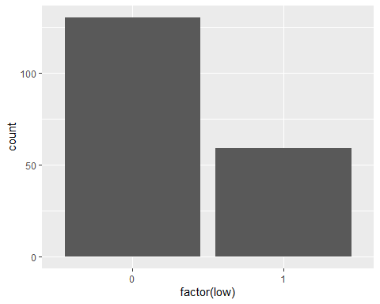

# Adding Citation in RMarkdown

This is my text. I want to add a reference here.(2)

# References

1. Mitra A, Soman B, Gaitonde R, Singh G, Roy A. [Data Science Methods to Develop Decision Support Systems for Real-time Monitoring of COVID-19 Outbreak](https://doi.org/10.28991/HEF-2022-03-02-08). Journal of Human, Earth, and Future. 2022 Jun;3(2):223–36.

2. Mitra A, Pakhare AP, Roy A, Joshi A. [Impact of COVID-19 epidemic curtailment strategies in selected Indian states: An analysis by reproduction number and doubling time with incidence modelling](https://doi.org/10.1371/journal.pone.0239026). PLOS ONE. 2020 Sep;15(9):e0239026.